Appendix C: IEEE 830 Template
Software Requirements Specification
for
Smart Home System
Version 3
Prepared by Soreja Adzajilic and Ernest Beqiri
Date: 25.04.2026

Table of Contents
Table of Contents 2
Revision History 4
1. Introduction 5
1.1. Purpose 5
1.2. Document Conventions 5
1.3. Intended Audience and Reading Suggestions 5
1.4. Product Scope 5
1.5. References 5
2. Overall Description 7
2.1. Product Perspective 7
2.2. Product Features 7
2.3. User Classes and Characteristics 8
2.4. Operating Environment 8
2.5. Design and Implementation Constraints 8
2.6. User Documentation 8
2.7. Assumptions and Dependencies 8
3. System Features 9
3.1. Device Management 11
3.2. Secure Login 11
3.3. Remote Device Control 11
3.4. Automation and Scheduling 11
3.5. Energy Monitoring and Usage History 11
4. External Interface Requirements 12
4.1. User Interfaces Overview 12
4.2. Hardware Interfaces 12
4.3. Software Interfaces 12
5. System Features / Modules 13
5.1. Device Management 13
5.1.1 Description and Priority 13
5.1.2 Stimulus/Response Sequences 13
5.1.3 Functional Requirements 13
5.2. Remote Device Control 13
5.2.1 Description and Priority 13
5.2.2 Stimulus/Response Sequences 14
5.2.3 Functional Requirements 14
5.2.4 System Model: Sequence Diagram 14
5.3. Automation and Scheduling 16
5.3.1 Description and Priority 16
5.3.2 Stimulus/Response Sequences 16
5.3.3 Functional Requirements 16
5.4. Energy Monitoring and Usage History 16
5.4.1 Description and Priority 16
5.4.2 Stimulus/Response Sequences 17
5.4.3 Functional Requirements 17
6. Nonfunctional Requirements 18
6.1. Performance 18
6.2. Security 18
6.3. Reliability 18
6.4. Usability 18

Revision History
Name | Date | Reason for Changes | Version
Soreja Adzajilic  Ernest Beqiri | 10.03.2026 | Initial Version | V1
Soreja Adzajilic  Ernest Beqiri | 28.03.2026 | Added UML Use Case Diagram | V1.1
Soreja Adzajilic  Ernest Beqiri | 09.04.2026 | Added UML Class Diagram | V2
Soreja Adzajilic  Ernest Beqiri | 16.04.2026 | Added descriptions to diagrams. Completed Section 1 (Introduction). | V2.1
Soreja Adzajilic  Ernest Beqiri | 17.04.2026 | Added Activity Diagram. Completed Sections 2-6. | V2.2
Soreja Adzajilic  Ernest Beqiri | 23.04.2026 | Added State and Sequence Diagrams. Fixed overall document. | V2.3
Soreja Adzajilic  Ernest Beqiri | 25.04.2026 | Added table of contents. Edited minor details. Final version. | V3

1. Introduction

1.1. Purpose
The purpose of this document is to define the software requirements for the Smart Home System. It describes the functional and non-functional requirements needed to design, develop, and implement a secure and efficient platform for managing smart home devices and automation. The system supports device registration, secure authentication, remote control, scheduling, and energy usage monitoring.
To illustrate how users interact with the system, this document includes a UML Use Case Diagram showing the workflows for the main actor:
- User: The primary actor who interacts with the system to register devices, log in securely, control devices remotely, configure automation schedules, and monitor energy consumption.

1.2. Document Conventions
This document follows standard IEEE 830-1998 formatting conventions:
- Bold text: Used for system actors and core feature names.
- Italic text: Used for external platforms or references.
- Requirement IDs: Each requirement is tagged: REQ-X.X for functional requirements, NF-X.X for non-functional requirements.
Requirements are expressed using the word "shall" to indicate mandatory functionality.

1.3. Intended Audience and Reading Suggestions
This document is intended for the following stakeholders:
- Developers: Focus on Sections 4-6 for interface specifications, system features, and functional requirements.
- QA Testers: Review Sections 5 and 6 for functional and non-functional requirements to drive test cases.
- Project Managers & Stakeholders: Start with Sections 1 and 2 for a high-level overview of goals and scope.
It is recommended to read the document sequentially from introduction through to system features for a complete understanding.

1.4. Product Scope
The Smart Home System is a secure application designed to provide core smart home services. Its primary objectives are:
- Provide secure user account creation and device management.
- Implement robust authentication to protect user accounts and device access.
- Enable remote control of connected smart devices from any location.
- Support automation rules and scheduling to control devices based on triggers or time.
- Monitor and display energy consumption data for all registered devices.
The system aims to improve efficiency, comfort, and energy awareness for individual users and households managing smart home environments.

1.5. References
The following documents and standards were used as the foundation for this specification:
- IEEE Std 830-1998: IEEE Recommended Practice for Software Requirements Specifications.
- Course Assignment: Software Engineering Laboratory Assignment Guidelines, Lodz University of Technology, 2026.
- UML Standard: Object Management Group (OMG) Unified Modelling Language Specification, Version 2.5.1.

2. Overall Description

2.1. Product Perspective
The Smart Home System is a standalone application designed for use by individual households and property managers. It does not replace or extend any existing home automation software but acts as a self-contained platform that may later integrate with external IoT infrastructure and third-party smart device ecosystems. The system functions as a centralized hub for all core smart home operations.

2.2. Product Features
The following diagram illustrates the core class structure of the system, showing the relationships between key entities such as Users, Devices, the HomeSystem, and the Notification service.

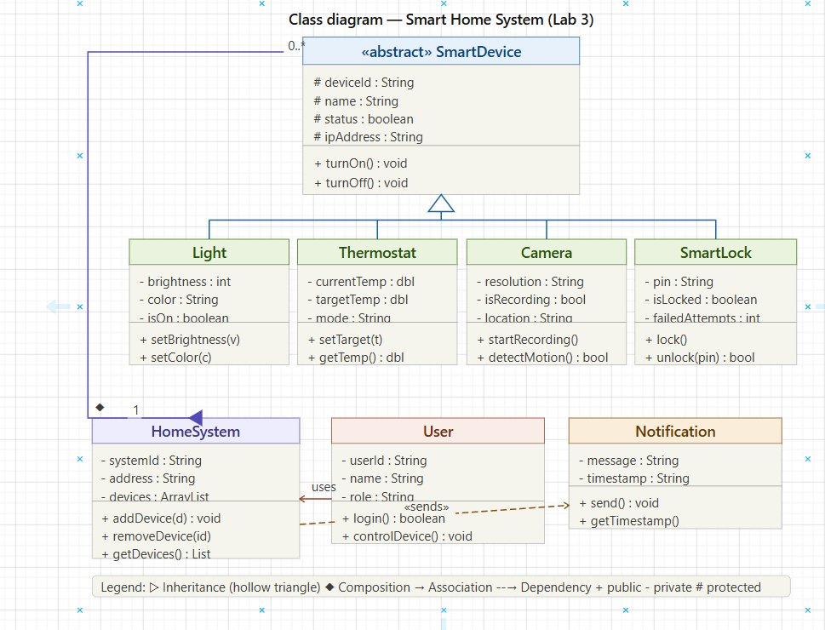
Figure 1: UML Class Diagram – Smart Home System
The system's main features, as modelled above, include:
- User account creation and device management
- Secure login and authentication via the User login() method
- Remote device control (turnOn/turnOff) for Light, Thermostat, Camera, and SmartLock
- Automation and scheduling through the HomeSystem's addDevice/removeDevice interface
- Energy usage monitoring and history
- Notification support for key events via the Notification module

2.3. User Classes and Characteristics
- Homeowners (Residents): Primary users who register, manage, and control all smart devices. They interact with the system most frequently and have full access to all features.
- Administrators: Manage system-level settings, user accounts, and have elevated permissions including admin reset capabilities for locked devices.
- Guests (Children): Limited users who may have temporary access to specific device controls granted by the homeowner.

2.4. Operating Environment
- Web-based or mobile application
- Runs on Windows, Android, or iOS
- Requires a stable internet connection
- Compatible with standard modern web browsers (Chrome, Firefox, Safari, Edge)
- Communicates with smart devices via Wi-Fi, Zigbee, or Z-Wave protocols

2.5. Design and Implementation Constraints
- The system must comply with current data protection regulations (e.g., GDPR).
- All user data and device telemetry must be encrypted at rest and in transit.
- The system must handle multiple concurrent users and devices simultaneously without performance degradation.
- Authentication must use industry-standard protocols (e.g., JWT tokens, 2FA support).
- The SmartLock shall trigger an alarm after 3 consecutive wrong PIN entries.

2.6. User Documentation
- User manual covering all core features
- Online help section accessible from within the application
- Interactive onboarding tutorial for new users
- Tooltips and inline guidance for complex features

2.7. Assumptions and Dependencies
- Users have a stable internet connection.
- A reliable database server is available and maintained.
- Secure authentication infrastructure is implemented and operational.
- Smart devices are compatible with supported communication protocols.
- Third-party services used for notifications remain accessible.

3. System Features
This section provides an overview of the platform's core features, illustrated by the Use Case Diagram below. Full technical details are in Section 5.

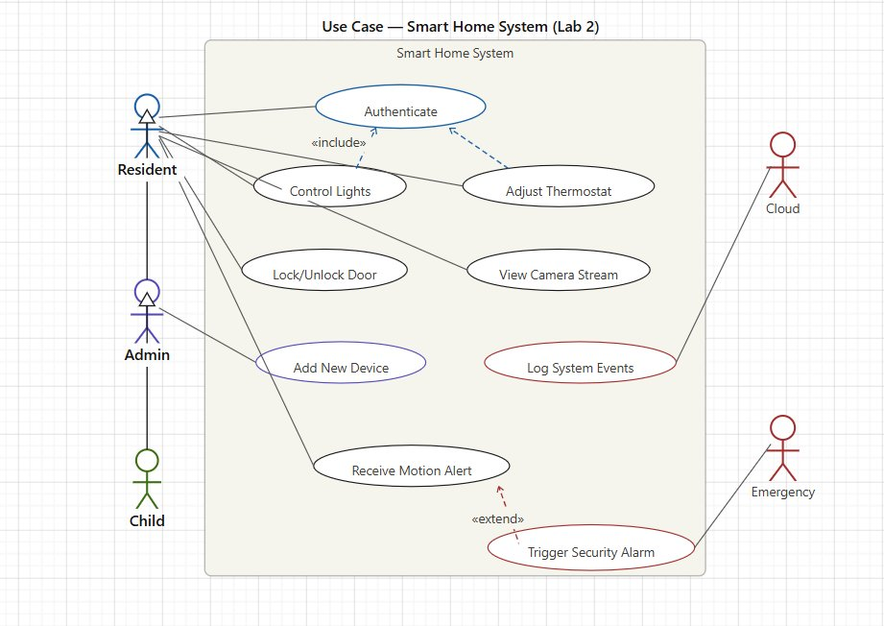
Figure 2: UML Use Case Diagram – Smart Home System
The diagram above shows the primary actors (Resident, Admin, Child, Cloud, and Emergency) and the use cases within the Smart Home System boundary, representing the complete set of interactions users can perform.

3.1. Device Management
Allows Admins to add new devices and users to manage existing device configurations. This is the entry point for all device-based features.

3.2. Secure Login
Provides authenticated access to the system using secure credentials via the Authenticate use case, which is included by Control Lights and Adjust Thermostat. The system validates login attempts and issues session tokens upon success.

3.3. Remote Device Control
Enables residents to remotely control lights, adjust the thermostat, lock or unlock the smart door, and view the camera stream from any location.

3.4. Automation and Scheduling
Allows users to receive motion alerts and configure automated responses. The Trigger Security Alarm use case extends Receive Motion Alert when an emergency condition is met.

3.5. Energy Monitoring and Usage History
Stores and displays historical energy consumption and system event logs, enabling users to track usage patterns and the Cloud to log system events for audit purposes.

4. External Interface Requirements

4.1. User Interfaces Overview
The system features a modern, web-based Graphical User Interface (GUI) designed to be fully responsive on both desktop and mobile devices. Key interface components include:
- Login & Registration Screen: Forms for account creation and secure login with clear validation feedback.
- Dashboard: Displays all registered devices, their current status, and quick-access buttons for all major features.
- Device Control Panel: An intuitive interface for remotely controlling individual devices with real-time status updates.
- Automation Screen: A rule-builder interface for creating and managing automation schedules and triggers.
- Energy Monitoring View: A graphical display of energy consumption history with filtering and comparison options.
All user interactions provide clear success or error feedback messages.

4.2. Hardware Interfaces
The system requires standard consumer hardware with internet access. Supported devices include:
- Smartphones (iOS, Android)
- Desktop and laptop computers
- Smart home devices: Light Bulbs, Thermostats, Cameras, SmartLocks
- Smart Hub for relaying commands between the app and devices
- Servers for backend processing and data storage

4.3. Software Interfaces
The system relies on the following software integrations:
- Database System: A relational database (e.g., MySQL/PostgreSQL) to securely store user profiles, device records, schedules, and energy data.
- Operating Systems: Windows, Android, and iOS for client-side compatibility.
- Authentication Service: Secure token-based authentication (e.g., JWT) for session management.
- IoT Gateway / Smart Hub API: An interface layer for communicating commands and retrieving telemetry from smart devices.

5. System Features / Modules

5.1. Device Management

5.1.1 Description and Priority
Priority: High. This feature allows users to register, configure, and remove smart devices from their home network. It is the foundation upon which all other system features depend.

5.1.2 Stimulus/Response Sequences
Stimulus: User completes the device registration form and submits details.
Response: The system validates the input, registers the new device in the database, and displays a success confirmation.

Stimulus: User updates device settings or removes a device.
Response: The system saves the updated configuration or removes the device record and confirms the change.

5.1.3 Functional Requirements
REQ-1.1: The system shall allow users to register a new smart device by providing device type, name, and connectivity details.
REQ-1.2: The system shall authenticate users during login using stored credentials before granting device access.
REQ-1.3: The system shall allow users to update device settings (e.g., device name, location, configuration parameters).
REQ-1.4: The system shall allow users to remove a registered device, revoking all associated access and schedules.

5.2. Remote Device Control

5.2.1 Description and Priority
Priority: High. This module handles the remote control of smart devices from any connected location. It is the core operational feature of the system.
The Activity Diagram below illustrates the complete workflow of user authentication: after the system requests credentials, it validates them. On failure, the user is prompted to retry. On success, a Fork triggers two parallel actions — Send Notification and Log Access Event — before the session ends.

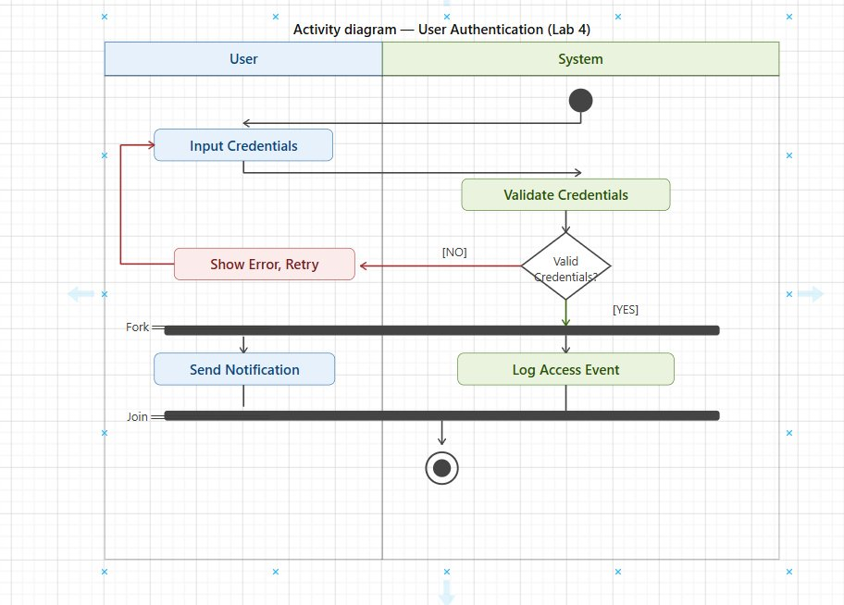
Figure 3: Activity Diagram – User Authentication (Smart Home System)
The diagram above shows the two-lane swimlane flow between the User and the System. After login validation (with retry on failure), a Fork node executes Send Notification and Log Access Event in parallel, joined before the final end state.

5.2.2 Stimulus/Response Sequences
Stimulus: User presses the On button for a Light Bulb device in the Smartphone App.
Response: The app sends sendCommand(lightId, ON) to the Smart Hub, which calls activate() on the Light Bulb. If the light responds OK, confirmON() and statusOK() are returned. If a timeout occurs, an error is displayed.

Stimulus: Device is unresponsive or times out.
Response: The system displays a "Device timeout" error message and cancels the command.

5.2.3 Functional Requirements
REQ-2.1: The system shall allow users to send control commands (on/off, parameter adjustments) to any registered smart device.
REQ-2.2: The system shall perform a connectivity and authorization check before processing any device command.
REQ-2.3: The system shall update and display the device status in real time upon successful command execution.
REQ-2.4: The system shall display a clear error message if a command fails due to device unavailability or timeout.

5.2.4 System Model: Sequence Diagram
The Sequence Diagram below details the message flow between system components (Resident, Smartphone App, Smart Hub, and Light Bulb) for the device control operation, including the alternative scenario for device timeout.

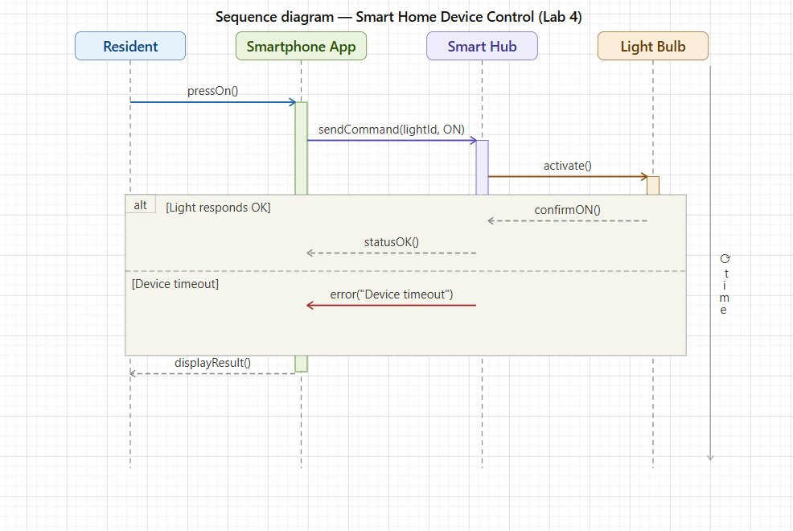
Figure 4: Sequence Diagram – Smart Home Device Control
The diagram covers the pressOn() trigger from the Resident through the Smartphone App, the sendCommand(lightId, ON) to the Smart Hub, and the activate() call to the Light Bulb. Two alternative flows are shown: [Light responds OK] where confirmON() and statusOK() are returned, and [Device timeout] where an error is propagated back. The final displayResult() is sent to the Resident regardless of outcome.

5.3. Automation and Scheduling

5.3.1 Description and Priority
Priority: High. This feature provides users with the ability to define time-based and trigger-based automation rules for smart devices, enabling autonomous operation and improved convenience.

5.3.2 Stimulus/Response Sequences
Stimulus: Authenticated user navigates to the automation section and creates a new schedule or rule.
Response: The system stores the automation rule in the Schedule Service and confirms its activation.

Stimulus: A scheduled trigger time or condition (e.g., motion detected) is met.
Response: The system automatically executes the associated device command and logs the action.

5.3.3 Functional Requirements
REQ-3.1: The system shall allow users to create automation rules that associate device actions with time-based or event-based triggers.
REQ-3.2: The system shall execute scheduled automation rules automatically without requiring manual user input.
REQ-3.3: The system shall allow users to view, edit, and delete existing automation schedules at any time.

5.4. Energy Monitoring and Usage History

5.4.1 Description and Priority
Priority: Medium. This module stores and presents a complete record of energy consumption and system events for all registered devices, supporting cost awareness and security auditing.
The State Diagram below models the lifecycle of the SmartLock within the system, showing how the lock transitions between key states based on PIN input and administrative actions.

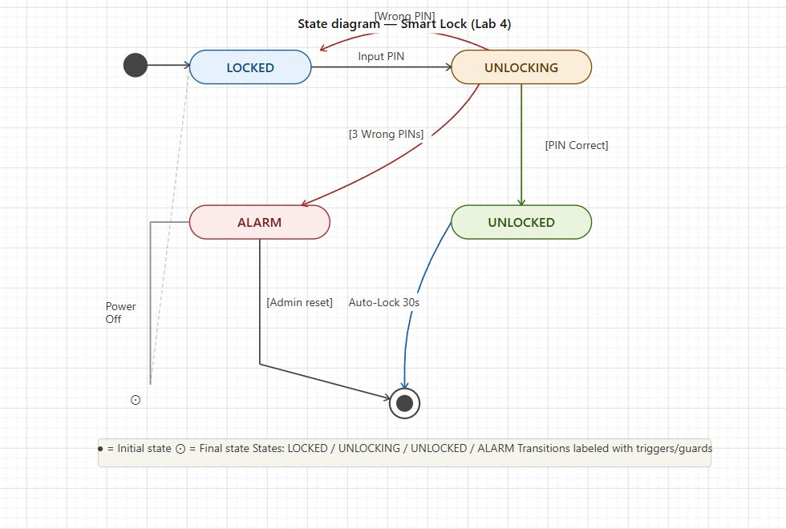
Figure 5: State Diagram – Smart Lock Lifecycle
The state diagram shows four states: LOCKED, UNLOCKING, UNLOCKED, and ALARM. From LOCKED, inputting a PIN transitions to UNLOCKING; if the PIN is correct the lock enters UNLOCKED and auto-locks after 30 seconds. Three consecutive wrong PINs trigger the ALARM state, which can only be reset by an Admin. Power Off from LOCKED leads to the final end state.

5.4.2 Stimulus/Response Sequences
Stimulus: Authenticated user navigates to the energy monitoring or system event log section.
Response: The system retrieves and displays a chronological graph and list of energy consumption data and logged system events.

5.4.3 Functional Requirements
REQ-4.1: The system shall retrieve and display a complete, chronological record of energy consumption for all registered devices.
REQ-4.2: Each energy record shall display the date, device name, consumption amount (kWh), and estimated cost.
REQ-4.3: The system shall log all system events (authentication, device commands, alarms) with timestamps for audit purposes.

6. Nonfunctional Requirements

6.1. Performance
NF-1.1: The system shall process and execute device control commands within 2 seconds under normal network conditions.
NF-1.2: The system shall support at least 500 concurrent user sessions without degradation in response time.
NF-1.3: The user dashboard and device status view shall load within 1.5 seconds on a standard broadband connection.

6.2. Security
NF-2.1: All user data, including account details, device telemetry, and energy records, shall be encrypted at rest and in transit using AES-256.
NF-2.2: The system shall enforce secure authentication and prevent unauthorized access to any user account or device.
NF-2.3: The system shall invalidate sessions after a period of inactivity of no more than 15 minutes.
NF-2.4: The system shall log all failed authentication attempts and trigger the SmartLock ALARM state after 3 consecutive wrong PIN entries.

6.3. Reliability
NF-3.1: The system shall maintain an uptime of at least 99.5% per calendar month.
NF-3.2: The system shall provide graceful error handling and display user-friendly error messages for all failure scenarios, including device connectivity failures.

6.4. Usability
NF-4.1: The user interface shall be fully responsive and functional across desktop, tablet, and mobile devices.
NF-4.2: New users shall be able to complete account registration, first login, and register their first device within 5 minutes without external assistance.

